BIOC 404 March 22nd, 2006
Jean-Philippe Demers ^_^

Protein NMR Spectroscopy Field Trip
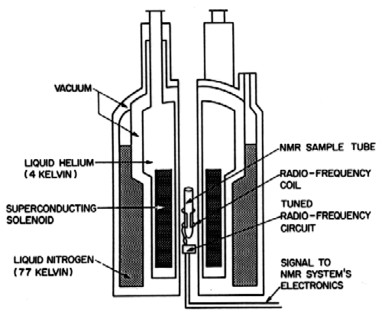
Today was the field trip at the Québec/Eastern Canada High Field NMR Facility (Pulp and Paper 023). The facility has two spectrometers: Varian INOVA 500 MHz and 800 MHz. The 800 MHz magnet is surrounded by 30 tons of iron (shielding) to reduce the spread of its magnetic field.

Cryoprobe
The large shiny coils that we see running on the floor are actually connecting the cryoprobe to a cooler and vacuum pump (which indeed produces the squeaking noise that you may have noticed). The probe coils are responsible, among other things, to detect the tiny electrical currents generated by the magnetization lying in the XY plane. Keeping the temperature of the probe at very low temperatures, 30 K in the present case, reduces the amount of thermal noise that is picked up. The signal-to-noise ratio (S/N) can be increased up to a factor of 2 to 4 compared to normal probes. Both spectrometers usually operate with a cryoprobe.

Hardware
A spectrometer is connected to some pieces of electronics and hardware which are contained in the two rectangular boxes aside the spectrometer. The electronics does not specially differ between the 500 MHz and the 800 MHz. The electronics is involved in the following tasks:
- Control the temperature of the sample;
- Help stabilize the magnet against mechanical vibrations;
- Generate radio-frequencies (rf) and amplify them before sending them through the transmitter coil;
- Detect the signal in the receiver coil and amplify it (pre-amplifier);
- Digitize the signal to the computer (Analog-to-digital Converter);

The data is then stored and processed in the computer workstation. Free-Induction Decay (FID) curves can be modified by multiplication by a function (see Lecture 3 - Signal Apodization); then the Fourier Transform applied to produce the actual spectrum in the frequency domain.

Measuring the length of a 90º pulse
In this experiment, we do not look for the individual components but rather for the relative intensity of the signal. As usual, magnetization starts on I^{z}. A rf pulse is applied along I^{y} so that magnetization flips towards I^{x}. The angle of which magnetization is tilted from the Z axis depends linearly on the duration of the pulse.
#1
1μs
#2
2μs
#3
3μs
#4
...
#5
#6
#7
#8
#14
#21
90º
180º
270º
Experiment:
Pulse length:
Spectra in the
frequency-domain
Signal
intensity
The experiment is repeated about 25 times, but each time the duration of the rf pulse is incremented by 1 microsecond. As NMR detects magnetization in the XY plane, the intensity is maximal when magnetization is tilted 90º from the Z axis, and then decrease to almost zero at 180º.

With the same sample, if we increase the receiver gain, we get a pattern that should be familiar from Organic Chemistry, provided that the sample is in water with traces of ethanol:
−CH₂−
1:3:3:1
−CH₃
1:2:1
Water
Ethanol
Signal
intensity
Frequency

Acquisition parameters
Looking at the data in the time-domain, we can observe a wobbing pattern. The FID spectrum looks like several beads following each other. This occurs when two or more similar frequencies are present, thus causing destructive and constructive interference in the signal.

Signal
intensity
Time

It was then showed that we could increase the intensity of the signal by increasing the gain, i.e. the ratio of output to input from the pre-amplifier. The noise was also amplified so there was no change in the S/N ratio. If one would increase the gain so much, some part of the signal would just be equal to the maximal value of the dynamic range of the digitizer (16 bits, so 2¹⁶ = approx 64,000):
Signal
intensity
Frequency
Ethanol
−CH₂−
Signal
intensity
Time
Maximal value
We then reduced the total number of data points. The result was that the FID was recorded only until the first destructive interference. With such a short FID, the signals get broader as the Fourier Transform process does not have enough information to reconstruct the fine details of the frequency spectrum.
Another parameter to look at is the digitization rate (also called the sampling rate), i.e. the rate at which data points are read from the spectrometer. If the rate is too slow, there will be aliasing in the FID, and again the Fourier Transform will have a hard time reconstituting the frequency spectrum. Indeed, it is possible to get artefact from peaks outside of the spectral width (e.g. the range of frequencies that we examine, e.g. about -0.5 − 12 ppm from the TMS frequency for protons); those peaks will appear folded, i.e. not at their correct frequency.
Signal
intensity
Time

Overcoming field inhomogeneity
A first difficulty is that the strength of the magnetic field varies along the length of the sample tube (in the Z direction). A molecule at the top of the tube would not resonate at the same frequency than if it would be at the bottom. To circumvent this difficulty, a process referred to as shimming is applied. In addition to the main coils that provide the 18.8-Tesla magnetic field, there are tiny coils (called shim coils) that surrounds the sample. A low electrical current is passed through those coils to generate additional magnetic fields to "fill-in" the inhomogeneities of the main field. Fields generated by those coils are in fact gradients along the Z axis: a coil provides a linear gradient; others provide a quadratic gradient and a cubic gradient, etc. Once we know the strength of the main field along the Z axis, the intensity of each current through shim coils is adjusted accordingly.

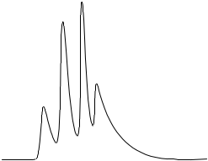
To demonstrate this effect, if we change the value of the linear coil by 1 ppm, we almost don't see the beading pattern anymore in the FID. Peaks become 1 ppm broad instead of ¹/₁₀₀ ppm or ¹/₁₀₀₀ ppm broad.
Signal
intensity
Frequency
Ethanol
−CH₂−
1:3:3:1

A second difficulty is that the strength of the main magnetic field can vary over the course if the experiment, especially if the experiment is lengthy. The field can be adjusted externally, but a reference is required. For that purpose, traces of D₂O are put in the solvent. The frequency of the deuterium reference signal is constantly monitored and the main field is adjusted consequently. We say that the field is locked.
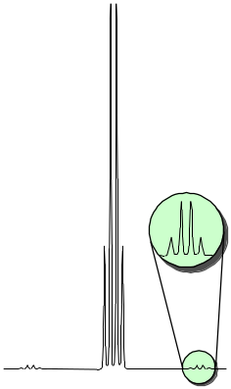
1.1% natural
abundance
= 125 Hz
¹²C peak
98.9% natural
abundance
¹³C satellite
peaks
Satellite sidebands
If we observe very carefully the ethanol methylene peak, we can see two small quartets on each side of the main peak. Where do those satellite peaks come from? Hint: together they account for 1% of the intensity of the main peak. Answer: those peaks arise from the coupling of the methylene protons with ¹³C nuclei, which are present in 1.1% natural abundance. The ¹²C nuclei, having I=0, don't show any through-bond coupling with ¹H. However, ¹³C nuclei have I=½ and hence a multiplicity of 2I+1 = 2. So when a ¹³C nucleus is present, the quartet is splitted in two, with a separation of 140 Hz. As for other J couplings, this value does not depend on the strength of the external field. Because of their low intensity, those satellite peaks are usually buried in the noise, unless the main signal is strong and the S/N ratio is high.

Functional MRI
What is Functional MRI?
- It is not the MRI imaging of human genitalia during coitus (for which an Ig Nobel was awarded to a Dutch professor in 2000). Ref: British Medical J. (1999) 319:1596

Rather, it is a type of brain imaging correlating what the patient does with the brain activity. As for MRI, it relies on T₂ relaxation contrast. It was discovered that hemoglobin is paramagnetic when not oxygenated and causes faster T₂ relaxation. This property can be exploited to tell the extent at which an area of the brain is oxygenated. The patient is asked to do a particular functional activity. MRI spectra before and just after the activity are compared. An increasing in the oxygenation of an area means that the area was previously more active. This is based on the principle that when a brain region is being used, arterial oxygenated blood will redistribute and increase to this area.

Tutorial for the peptide assignment practice question

We have to assign signals in the downfield region of the 1D ¹H spectrum of [Ace]DFMLHH[NH₂].

General procedure (a ruler is always useful):
- Start by spotting the H_{N}/H_{α} crosspeaks on the TOCSY in the fingerprint region (4.5 ppm / 8.5 ppm). Those signals correlate the amide proton of one amino acids to its own alpha proton.
- Identify the spin systems by going vertically from the H_{N}/H_{α} crosspeaks to the amide/sidechain crosspeaks (8.5 ppm / 1.5-3.5 ppm). Try to spot amino acids which have "special features"; in our case, the Leu spin system is easy to identify as it has two methyl signals. Those special amino acids will be the landmarks that will help you "crawl" the NOESY spectrum.
- 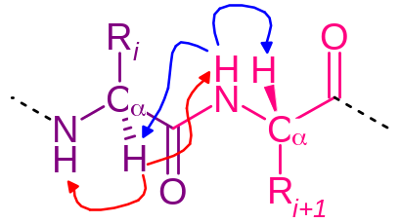Find the through-space backbone correlation on the NOESY in the fingerprint region. The crosspeak where TOCSY, NOESY and COSY overlap represents amino acid i. Then, horizontal movements (H_{α} frequency constant) relate the i and i+1 amino acids, while vertical movements (H_{N} frequency constant) relate the i−1 and i amino acids. When you hit the last or the first amino acid in the sequence, double-check that there is no other crosspeak that matches. Sometimes, two amino acids can have the same H_{α} or H_{N} frequency (here, the last two His have the same H_{α} frequency), so keep an eye open for peaks that overlap.
- Correlate the sidechain crosspeaks to the assigned H_{N}/H_{α} crosspeaks on the TOCSY (signals are in the same spin system) AND in the NOESY (signals are close in space). For example, all H_{β} signals (2.5-3.5 ppm) can be correlated via the TOCSY, as well as the H_{γ} of Met and Leu, and the two methyl of Leu. The aromatic spin system of Phe and His residues can only be identified via NOESY, as those systems have crosspeaks with H_{α} and H_{β} from their own amino acids. Indeed, the 1D peaks at 7.33, 7.85, and 8.66 ppm belong to the His aromatic moieties, and the multiplets at 7.29 to 7.4 ppm are the Phe phenyl ring.
A few notes:
- Remember that some amino acids have multiple spin systems, which are not connected by the TOCSY spectra. Connect these using the NOESY. (Hint: this could be useful if asked to draw the spin systems of given amino acids on a hypothetical exam.)
- Be careful however when using NOESY to correlate isolated spin systems, as it contains information about both intra and inter-residue contacts.
- The imidazole (NH) proton of His exchanges with water and can be seen only:
  - In organic solvents;
  - Perhaps when the pH is decreased to ~3-4. At low pH, the histidine ring becomes protonated.
- In the practice question, the two His residues have a couple of signal overlapped.
- The most downfield signal (8.66 ppm) integrates for more than 2 protons. This could mean that there is yet another signal at that frequency, like an impurity.



